Installing INFORMS LK-P12 Firmware
Prerequisites:
- Install LK-P12 driver

- Connect printer to PC
- Launch the FW DOWNLOAD PROGRAM
- Change Model to: LK-P12
- Select Port: USB {Optionally COM port}
- Select FILE OPEN & select the LK-P12_V1.14_ZPL_INFORMS.bin or newer firmware file. Click Open.
- Click Printer F/W.
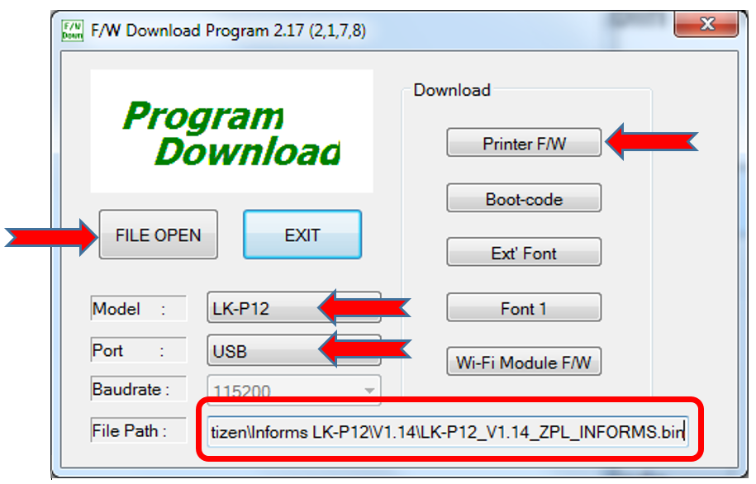
- You will see the following warning. Click Yes.
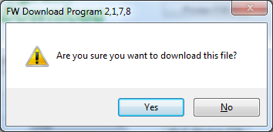
- There will be a Downloading message on the printer and it will play a song at the conclusion. The printer will power down.
- Click OK in the Download window.
- Click Exit.
- Power up printer. Press the Feed button. If the label does not feed to tear off then use the Mobile Label Printer Utility to set the printer to Gap.

