

**Installing the INFORMS LK-P12Z Printer Driver-1.00**

***NOTES AND PREREQUISITES:***

* All downloads can be obtained from the Informs LK-P12 Support page: [**http://www.informsinc.com/lkp12support/**](http://www.informsinc.com/lkp12support/)
* At power up, verify printer firmware is at **S/W VER v1.14 ZPL or higher**. If it is not at this firmware level complete this procedure and then update the firmware.
* ***Be prepared to reboot your computer at the conclusion of the driver installation.***

1. Launch the **INFORMS LK-P12Z Printer Driver-1.00.exe** file to install the driver.
2. You may see the following error. Click OK to proceed.

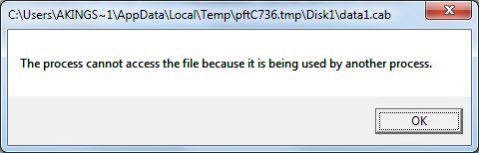

1. The Driver Installation screen will appear. Select the Informs LK-P12 printer checkbox and click **Installation**.

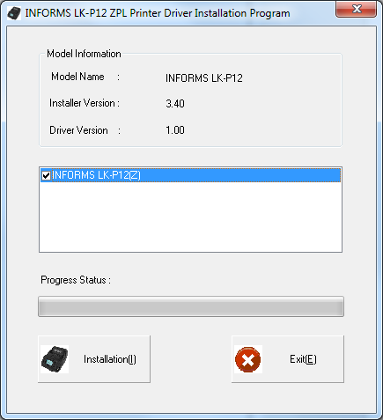

1. Select the correct **Operating System** information and **printer port** and click **OK**.

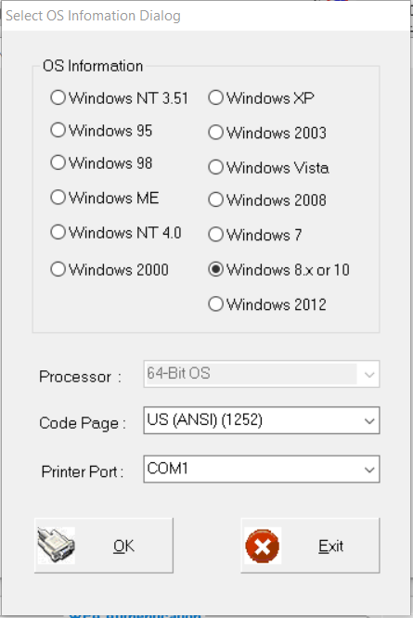

1. Follow the instructions in the USB Connection Warning window and Click **OK**.
2. You may get this warning message. Select “**Install this driver software anyway**”.

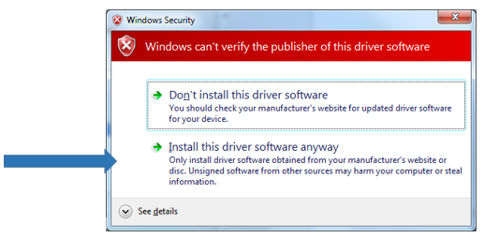

1. If the printer will not be the default printer uncheck the checkbox. Click **OK**.

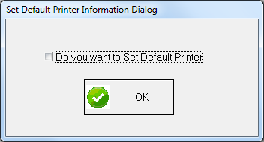

1. Click **OK** to reboot the Computer.

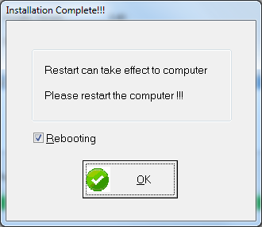

**Devices and Printers folder printer description:**

