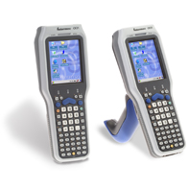
Intermec CK31 – Quick Start Sheet

When you use the Intermec CK31 Mobile Computer with Cardinal Health’s IMPRESS® system, there are a few areas on the device that you need to be concerned with: Communications Settings (wireless radio/802.11bg connectivity) and Data Collection (scanner) Settings. Both of these can be found in the Intermec Settings Applet.

Intermec Settings Applet
(Scanner Settings / Wireless Settings)
Use the Intermec Settings applet to gather, view, and update device configuration settings.

Configuring the CK31 With Intermec Settings
Use Intermec Settings to configure the CK31 and view system information.
Opening Intermec Settings
You can open Intermec Settings while running any application.
To open Intermec Settings
1 Tap the Start icon or press and then . The Start menu appears.

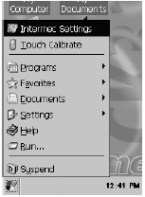
2 Select Intermec Settings. The Intermec Settings application appears.
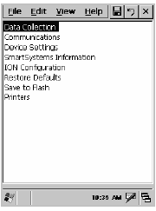

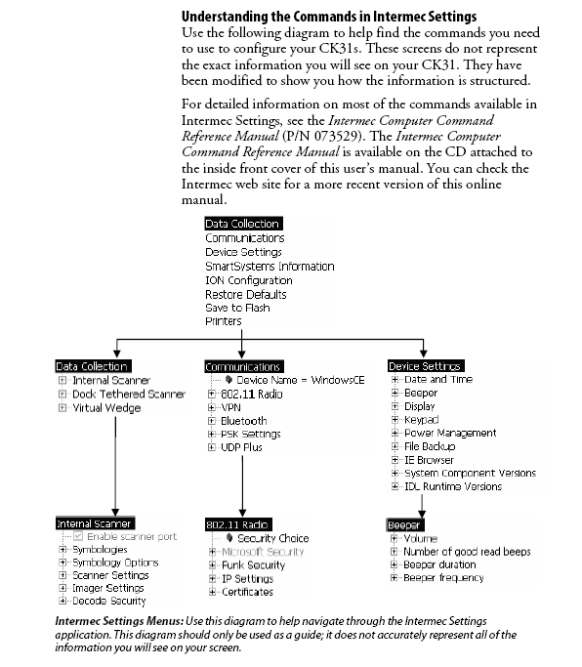

Frequently Asked Questions:

Q: When I go to the “Internet Explorer” icon, I get a “cannot connect” window. What’s wrong?
A: You’ve lost your network connection. If you had been connected on this device previously, you may have gone outside the wireless coverage area. Move back to your normal coverage area and see if you reconnect. If you have not connected on the device before, check with your IT department to make sure the device’s Wireless Profile is set up properly, and that your wireless network is active. (Instructions for configuring the Wireless Profile can be found at the end of this document.) You can also check your wireless connection by clicking on the icon on the bottom right of your screen.
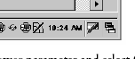

Q: How can I tell when I need to re-charge my device?
A: To view the status of this battery, tap Start icon > Settings > Control Panel > the Power icon > the Battery tab to view the current status of both the main battery and the backup battery. Tap ok to exit.

If your computer shuts down because of low battery conditions, your computer does not operate. This is done to ensure that data is protected. Although the battery does protect the data against loss for several hours, you should connect your computer to a power source when you first detect a low battery condition.

Q: What do I do if my device is frozen? It won’t respond, and seems to be locked up.
A: If this happens, you may need to do a “Warm Boot” on the device. Performing a warm-boot may be necessary to correct conditions where an application stops responding to the system. It does, however, unload all running programs, so you will need to login to IMPRESS® after the warm boot.

Press and hold the I/O (power) key for ten seconds, then the CK31 Computer continues from the screen you were at before you performed the warm-boot.

Configuring Scanner/Imager
Tap Start > Settings > the System tab > the Intermec Settings icon to access the applet, and then tap “Data Collection”. Here, you can activate symbology, add postamble characters (Internal Scanner > Symbology Options > Postamble), and change other scanner settings. The postamble should be: \x0D for an “Enter” postamble character.
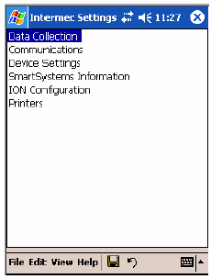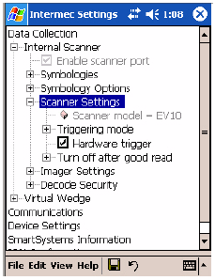

Configuring Your Wireless Network
To start 802.11b/g communications on the CK31 Computer, tap Start icon > Intermec Settings > Communications - to access the settings for the 802.11b/g radio module.

In this section, you will define your wireless network settings, including DHCP or Static IP address, security settings (Funk or Windows Security), and other wireless security settings (i.e. WEP, 802.1x, LEAP, etc.). NOTE: If you are entering a WEP Key in Hexadecimal (HEX), you need to put the following in front of your WEP Key: 0x

